





MASTER
ASSESSMENT
REPORT
DATE: 21st May 2024
Administration

VERSION: 1.2

Document History
Document version | Remarks | Submitted  By | Submission  Date | Approved BY | Approval  Date
1.0 | First Draft | k&S Digiprotect | 06-May-2024
1.1 | Second Draft | K&S Digiprotect | 17-May-2024
1.2 | Final Draft | K&S Digiprotect | 21-May-2024

Table of Contents
Introduction 4
Objectives 4
General Information 5
SPOC Information 5
Department Hierarchy* 6
Observations 7
Data Flow Diagram (DFD) 10
Data Mapping and Inventory 11
Recommendations 12
Action Plan 12
Requirements 12
Conclusion 13
Appendices 13
Appendix A 13

Introduction
India Shelter’s Admin Department manages office maintenance and support along with overseeing travel arrangements and event logistics, our team is dedicated to upholding efficiency and driving our objectives forward. Additionally, they handle office supplies, rent agreements, courier logistics, and maintain attendance systems.
This report encapsulates critical insights for As-Is study, derived from the initial interview conducted with the Administration Department of India Shelter Finance Corporation Limited (ISFC) for the implementation of ISO/IEC 27001:2022 and compliance with the Digital Personal Data Protection Act (DPDPA).
The overarching objectives of this interview were dual fold: first, to gain an understanding of the departmental structure, and second, to delve into the core operational processes of the Administration Department. Additionally, the interview aimed to assess the existing information security practices, focusing on evaluating adherence to DPDPA requirements and the readiness for ISO/IEC 27001:2022 implementation.
By delving into the details of the department's organizational setup, operational workflows, and data handling procedures, this report aims to identify both the strengths and areas of improvement in information security management and DPDPA compliance within the department.

Objectives
- Understand the departmental hierarchy and reporting structure
- Learn the existing processes of ISFC’s Admin Department
- Mapping of existing processes with documented processes
- Offer recommendations to optimize the existing processes

General Information
Organization Name | India Shelter Finance Corporation Limited
Department Name | Administration Department
Date of the Assessment | 18th March 2024  21st May 2024
Location | 3rd Floor, Basement(-1) India Shelter HQ, Gurugram
Meeting Duration | 45 minutes, 30 minutes
Attendees (ISFC) | Pankaj Gupta, Rajesh Kumar, Purushottam, Sunil Kumar Sharma
Attendees (Digiprotect) | Lalit Mohan Joshi, Sushil Menon, Manav Mahajan, Adhita Razdan

SPOC Information
Project SPOC: Dheeraj Yadav
Contact Information:
Email ID: dheeraj.yadav@indiashelter.in

Project Coordinator: Sunil Kumar Sharma
Contact Information:
Email ID: sunil.sharma2@indiashelter.in

Department SPOC: Pankaj Gupta
Contact Information:
Email ID: pankaj.gupta@indiashelter.in

Department Hierarchy*

* As informed during the meeting

Observations
S. No | Key Activities | Observations and Asks | Remarks
 | Office Maintenance and Support  - Limited maintenance within office premises. Rest is taken care by the building management.  - Limited maintenance covers – Furniture & fixtures, stand-alone air conditioners, A/V(audio/video) maintenance (e.g., Conference hall TVs).  - No PO released for order value less than Rs.10,000. Transaction is made based on email approval.  - HVAC system maintained by Building Management.  - House-keeping Staff also provided by the Building Management. | NA | To be verified by ISFC regarding maintenance of:  - A/V(audio/video)  - Stand-alone air conditioners
 | Travel & Event Management  - Only Air ticketing is centrally managed.  - For other modes of travelling, the employees make bookings on their own and then get reimbursed.  - Does not have dedicated vendors, they seek quotes from 2-3 vendors and the lowest bidder is issued a PO.  - Any events hosted by the company; all logistics are taken care by the admin team. The process is the same- they would reach out to 2-3 vendors and the lowest bidder is issued a PO.  - Very limited international travel happens in ISFC, mostly C-Suite travels outside India.  - Forex for such travels are also handled by admin team.  - Hotel booking for C-Suite is also done by Admin team. The process is the similar to ticketing where 2-3 vendors are asked for a quote and the lowest bidder is issued a PO. | NA | - Reimbursement Process to be explained by ISFC.  - A proper travel management process needs to be defined by ISFC admin team so that any organizational information or personally identifiable information of employees is funnelled via the admin team to any third party vendors/partners.
 | Physical Security  - Security guards are outsourced via vendor through a lowest quote process  - Security guards are changed on a yearly basis  - All visitors have to provide details at the reception counter (such as name, mobile, address, purpose of visit, in/out time, signature)  - Access Cards for employees contains Name, Employee ID  - Access card logs stored in ESSL Software. Logs can be accessed by Rajesh and are sometimes shared with HR Ops Department upon request.  - 2 vendors for CCTV – IGZY and Dahua.  - CCTV footage retention: On cloud – 7 days, Local – 30 days  - Access to CCTV footage with Admin team as well as Vendors  - In case access is required for CCTV footage, query is raised to admin team through email  - Employees requesting access to CCTV footage must have prior approval of respective department head.  - CCTV footage is shared via mail through a link generated by the vendor. The link is generated with selected time period as requested.  - CCTV footage is centrally monitored through HQ. No branches have access to footage.  - CCTV Vendor shares daily report. | - Current security vendor has been providing services for last 10 years  - High dependency on one individual for Biometric system (refer point e)  - Request for CCTV Footage should also loop in HR, Legal, and Risk Departments, since it may have an impact on the organization  - CCTV signage only in HQ not in branches  - CCTV footage is confidential and considered as PII data hence, vendors having access to PII is not recommended, unless the contract between ISFC, and the vendor has data protection clauses defined  - Incident management, in terms of loss of physical assets, theft, vandalism, and other unlawful activities physical security team should be kept in loop  - Visitor information in physical form(register) has been retained since inception  - No visitors badge issuing process in place
 | Office Supplies  - General office supplies are taken care of by the Admin team, except IT and Marketing materials.  - Branch Office supplies are sourced locally, and reimbursement is claimed. | NA | - Reimbursement Process for Branch Offices to be confirmed
 | Rent & Leasing  - All offices’ rent and leasing done by Admin team | NA
 | Courier Management  - Admin department handles Courier services between HO and Branch offices of ISFC. | NA
 | Others  - Data stored on individual OneDrives  - EPABX (Suvision) is managed by Admin team | NA

Data Flow Diagram (DFD)
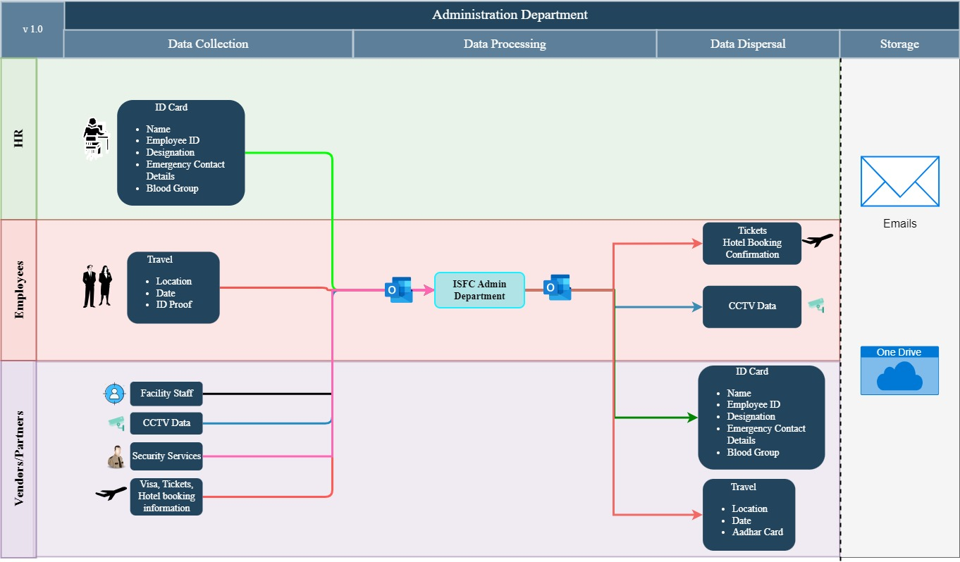

Data Mapping and Inventory
S. No | Data Category | Description | Purpose | Data Owner | Storage Location | Data Classification* | Retention Period | Legal Obligation
 | Travel Bookings | Details of travel bookings for employees | Facilitate employee travel | Admin Team | Emails/One Drive | Non-PII/ Private | Not Defined | NA
 | Event Registrations | Registrations for external events and meetings | Organize corporate events | Admin Team | Emails/One Drive | PII/Sensitive | Not Defined | Consent Required
 | Visitor Logs | Records of visitors entering the premises | Ensure premises security | Admin Team | Physical Registers | PII/Sensitive | Not Defined | NA
 | Access Logs | Logs of access to office premises | Monitor facility access | Admin Team | ESSL | Non-PII/ Private | Not Defined | NA
 | Employee Travel Profiles | Profiles containing employee travel preferences and requirements | Plan and manage employee travel | Admin Team | HR Database | PII/Sensitive | Not Defined | Consent  Required
 | Vendor Information | Contact details and contracts with event vendors | Engage with event vendors | Admin Team | Vendor Database | Non PII/Restricted | Not Defined | Contractual necessity
 | Security Incident Reports | Reports of security incidents and breaches | Record and address security incidents | Admin Team | Emails/One Drive | Non PII/ Confidential | Not Defined | Legitimate Interest
 | Facility Maintenance Records | Records of maintenance activities for physical security equipment and facilities | Ensure physical security infrastructure reliability | Admin Team | Maintenance Logs | Non PII/ Private | Not Defined | NA
 | CCTV Footage | Video recordings from CCTV cameras monitoring premises | Monitor and investigate security incidents | Admin Team | CCTV Server | PII/Sensitive | Cloud: 7 days  Local: 30 days | Legitimate Interest
*Refer Appendix A

Recommendations
- Streamline Purchase Order Process:
- Standardize the purchase order process for transactions below Rs.10,000 to ensure consistency and accountability.
- Implement a formal purchase order (PO) process for all transactions to enhance financial control and auditability.

- Centralize Travel and Event Management:
- Consolidate travel and event management activities under a centralized system to improve coordination and streamline vendor selection processes.
- Explore the use of dedicated travel management system to facilitate booking, reimbursement, and data sharing securely.

- Vendor Diversification for Security Services:
- Conduct thorough due diligence on potential security vendors to ensure alignment with data protection requirements and industry best practices.

- Employee/Visitor Badge Issuance Protocol:
- Implement protocol for employees to wear ID card at all office locations to prevent unauthorized access to premises.
- Implement visitor badge issuance protocol at all office locations to enhance visitor identification and tracking.
- Provide training to reception staff on proper badge issuance/verification procedures, and visitor management best practices.

- Document Data Management Review:
- Conduct a comprehensive review of document management practices, including data classification, storage, sharing, and retention policies, to ensure alignment with data protection and privacy requirements.
- Establish clear guidelines for handling sensitive documents, including encryption protocols and access controls, to minimize the risk of unauthorized disclosure.

Action Plan

Requirements (ISFC to share the following)
- Documentation of Policies and Procedures
- List of Vendors – Name & Nature of business of 6 Vendors received.
- CCTV Vendor Daily Report
- Does Administration team collect/store/process Customer Data? – No (As informed during meeting on 21st May 2024)

Conclusion
In conclusion, the implementation of encryption and access controls is essential for securing sensitive information shared through digital channels. By adopting encryption technologies, establishing access control mechanisms, and implementing secure communication protocols, the department can protect confidential data, mitigate the risk of unauthorized access or interception, and ensure compliance with data protection regulations.
Ongoing training and awareness programs will empower staff members to securely share data while adhering to organizational policies and regulatory requirements. Regular monitoring and review processes will help maintain the effectiveness of encryption and access control measures, adapt to evolving security threats, and uphold the department's commitment to data security and confidentiality.
Through these proactive measures, the Admin department can enhance its security posture, instil trust among stakeholders, and mitigate the impact of potential security incidents.

Appendices

Appendix A
Data Classification | Definition
Sensitive Data | Information that, if disclosed, altered, or destroyed without authorization, could cause significant harm to an individual, organization, or entity. This often includes financial records, medical information, and PII.
Restricted Data | Highly sensitive data tightly controlled due to legal, regulatory, or contractual requirements. Access is limited to authorized personnel, and any unauthorized disclosure may result in severe consequences.
Private Data | Information considered confidential and intended solely for specific individuals or groups within an organization. It requires protection from unauthorized access to maintain privacy and uphold confidentiality agreements.
Confidential Data | Privileged or proprietary information of an organization requiring protection from unauthorized access, disclosure, or alteration.
Public Data | Information that is freely available and accessible to the general public without restrictions or limitations. It does not contain sensitive or confidential information and can be openly accessed and used for various purposes such as research, analysis, and public interest initiatives.
PII (Personally Identifiable Information) | Data that can identify, contact, or locate an individual, either alone or in combination with other information. For example - names, addresses, official identifiers (Aadhar, Pan, DL, biometrics, etc).
Non-PII | Data that, while not personally identifiable, however may still require protection due to its sensitivity or confidentiality. This may include corporate financial information, proprietary research data, or internal communications.

-----------------------------------End of Report for Admin Department---------------------------------

